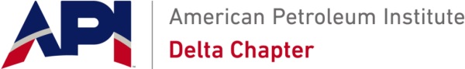
21th Annual Sporting Clays Tournament 2026
Date: Friday, June 5, 2026
Location: Covey Rise Lodge – Husser, LA
Visit online to view registration form and sponsorship opportunities
https://api-delta.org/event/21st-annual-sporting-clays-tournament-2026/
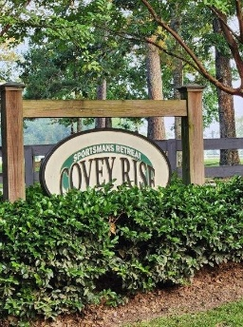 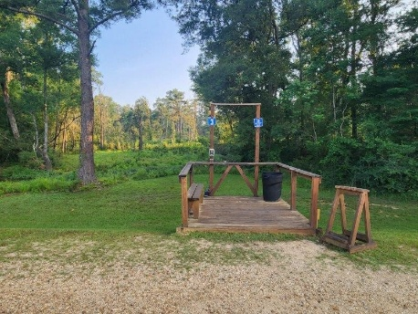 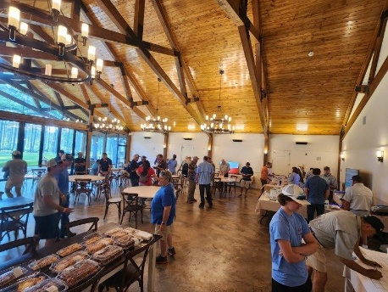
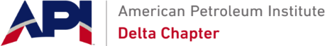
Fellow Petroleum Industry Sporting Clay Enthusiast,
The API Delta Chapter of New Orleans is proud to announce that we are holding our 21st annual Family Sporting Clay Tournament on Friday, June 5, 2026, at the Covey Rise Lodge located in Husser, LA. The annual API Family Sporting Clay Tournament promotes friendly competition, and sporting clay skills to our oil field industry participants and their families.
This event offers a wide range of competition for both the family and the individual. In the interest of safety, participants must be 14 years or older. The tournament will start on Friday, the registration starts at 7:30 AM shooting time starts promptly at 9:00 AM. Shooters should be ready for safety meeting at 8:30 AM.
The main event will present a multi-stand, 100 clays course. Awards will go to high individual and team winners based on Lewis Class Scoring. Additionally, we will have a few side games including longbird and .410 Challenge.
Proceeds from the tournament are used to support API Delta Chapter activities and programs, awards, scholarships, and the ongoing promotion of the petroleum industry in local schools and universities. Through your generosity and participation, API Delta Chapter has been able to provide ongoing support and funding for programs such as the following:
- Over $230,000 in scholarships since the start of the program to support deserving students from the API-Delta area
- Contributed over $200,000 to the Louisiana Children’s Museum, Bayou Country Children’s Museum, and Children’s Museum of St. Tammany
- Teacher of the Year Awards to local teachers in excess of $6,000 yearly with lifetime of over $250,000
- Mini Grants program to teachers, designed to help fund the purchase of supplies and teaching equipment.
- The Energy projects division of the Greater New Orleans Science & Engineering Fair was started by our Chapter. Monetary awards recognize students with winning science projects in the energy category, along with their teachers.
- The annual API-Delta Meritorious Service Award that recognizes local individuals for their outstanding service and leadership in the oil and gas industry and community service.
Your support of the tournament will ensure its success and help API-Delta Chapter continue its efforts to promote the petroleum industry in the region.
A registration form and sponsorship flyer are enclosed. You can also go to our website http://www.api-delta.org/events for tournament information and forms.
We look forward to seeing you at this year’s API-Delta Chapter Family Sporting Clay Tournament and thank you in advance for your generous support.
Sincerely,
Barney Paternostro
LLOG Exploration Co., LLC
Visit online to view registration form and sponsorship opportunities
https://api-delta.org/event/21st-annual-sporting-clays-tournament-2026/

